Master -slave

1. Create 1 ec2 instance as Master

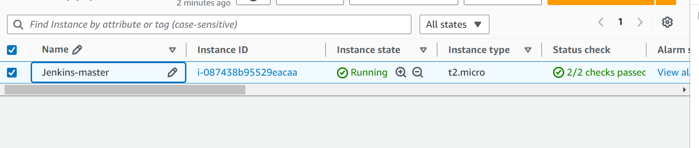

1. Install java

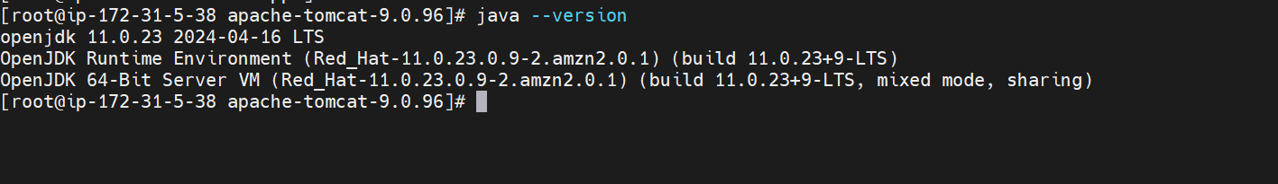

1. Install Jenkins as war application

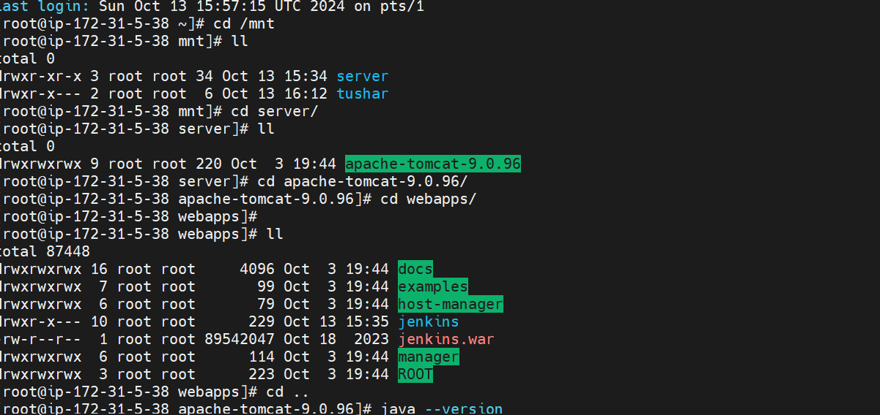

1. Login Jenkins

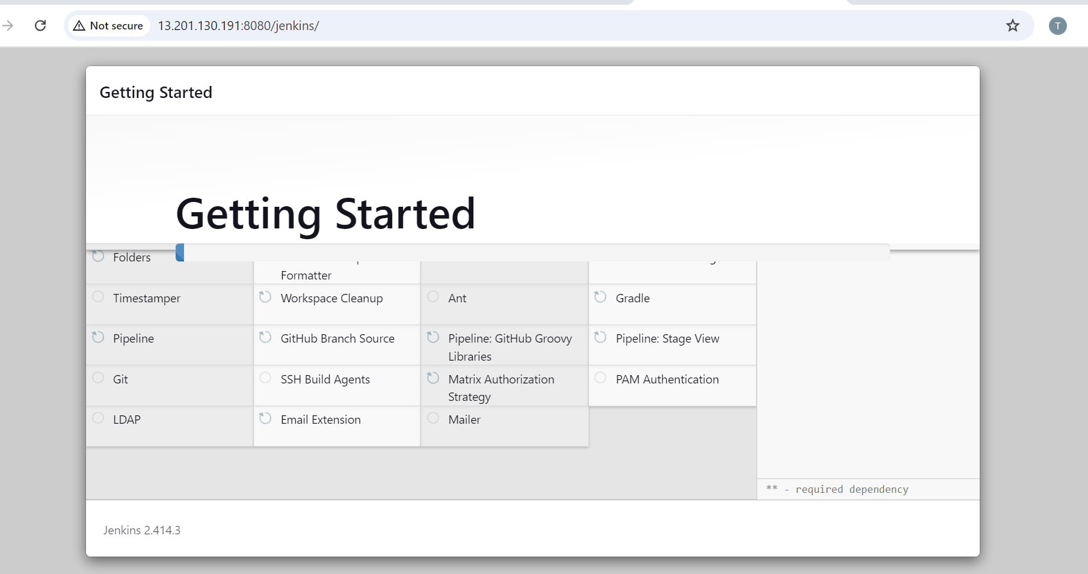

1. Create ec2 instance as Slave
2. Install java and create folder as remote repo

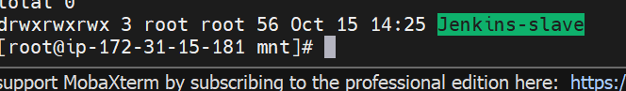

1. JNLP method

Go to Manage Jenkins → Security → Agents → select TCP port

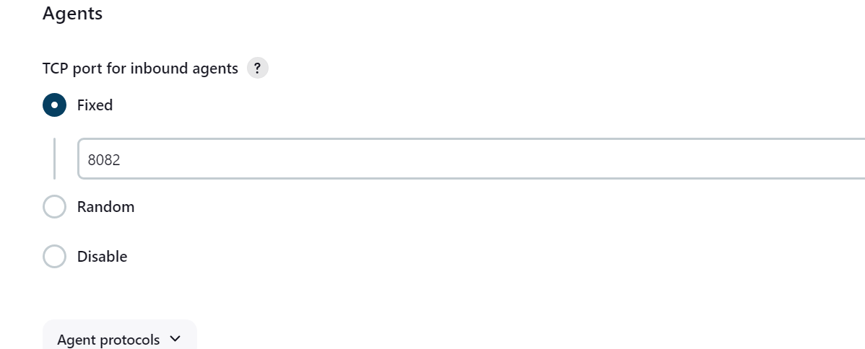

1. Create slave connection

Go to - Dashboard → Manage Jenkins → Nodes

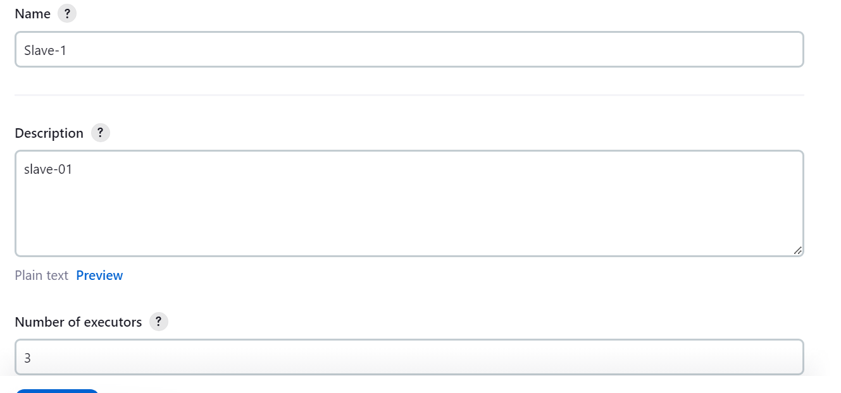

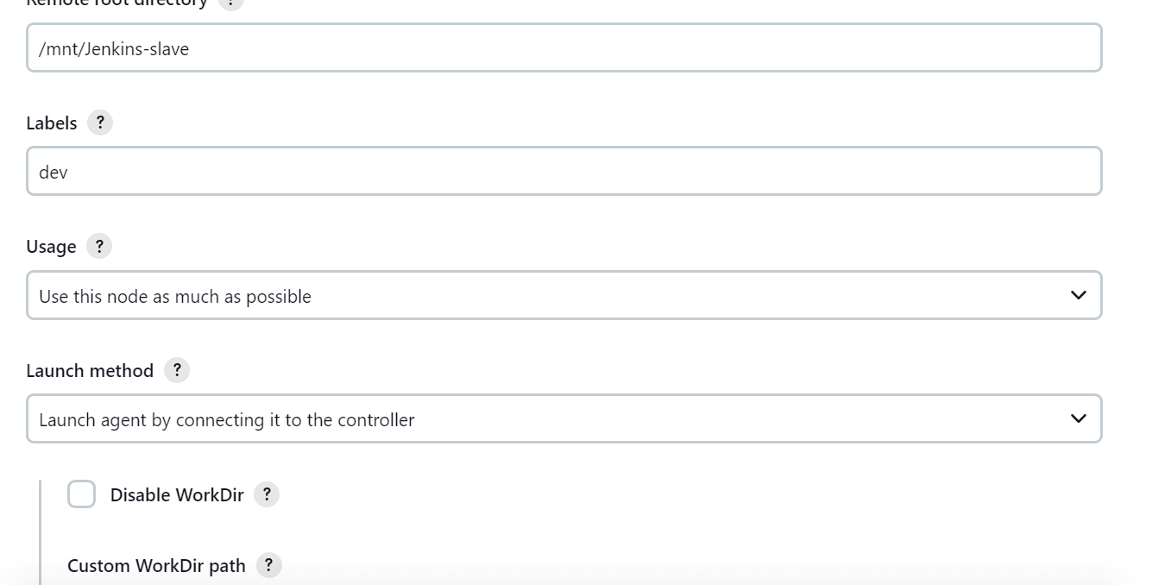

1. Run the command linux command and connect

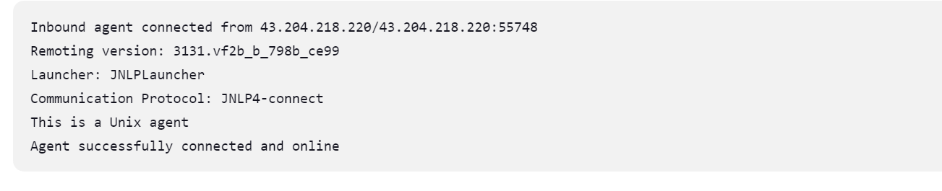

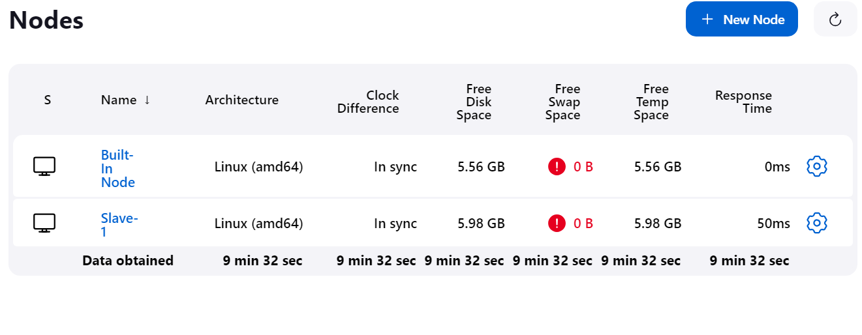

1. Create build

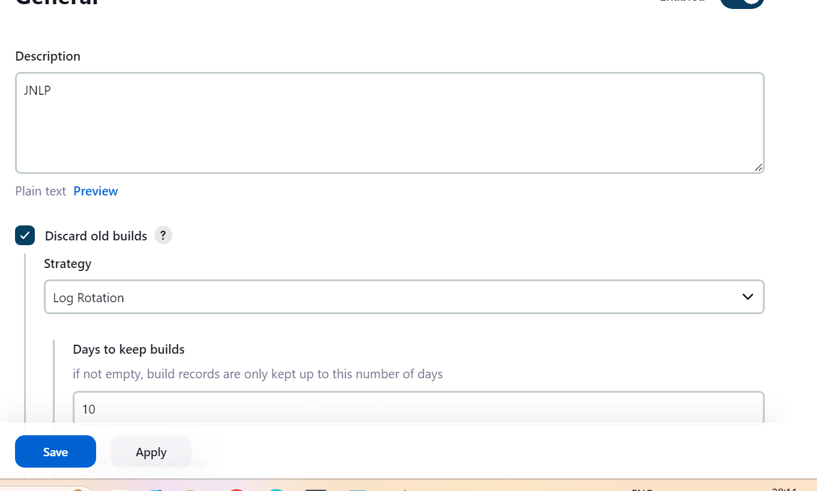

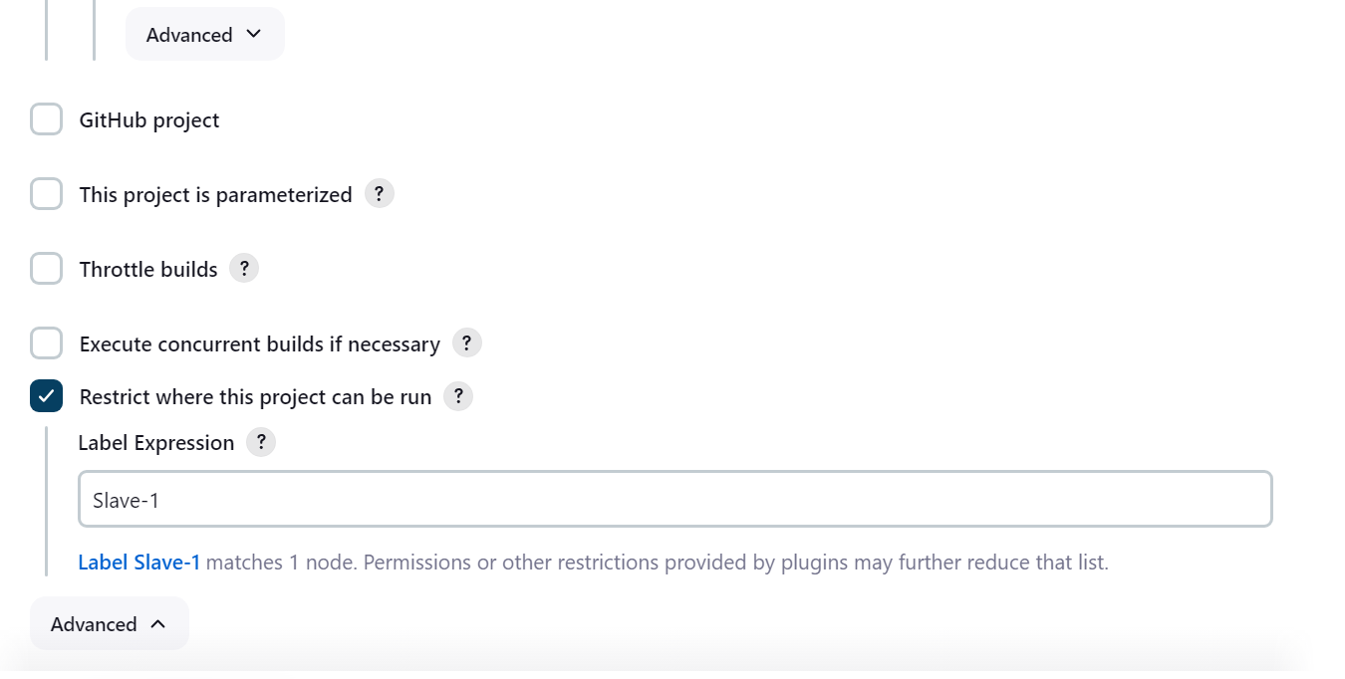

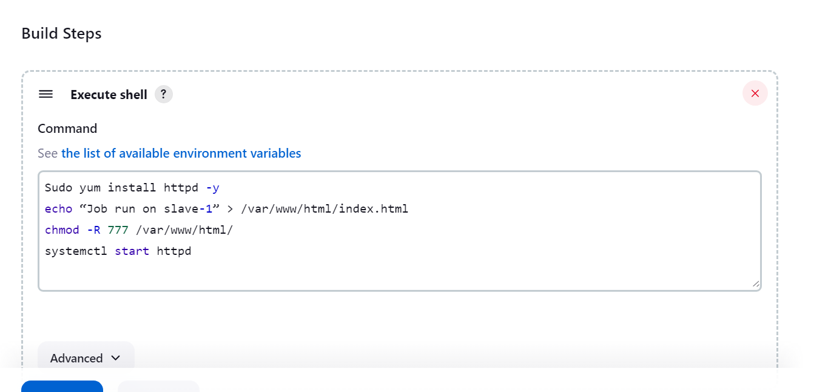

1. Then build now & check

Started by user [Tushar Chavan](http://13.201.130.191:8080/jenkins/user/412tushar)

Running as SYSTEM

Building remotely on [Slave-1](http://13.201.130.191:8080/jenkins/computer/Slave-1) (dev) in workspace /mnt/Jenkins-slave/workspace/JNLP

[WS-CLEANUP] Deleting project workspace...

[WS-CLEANUP] Deferred wipeout is used...

[WS-CLEANUP] Done

[JNLP] $ /bin/sh -xe /tmp/jenkins5572664835808980290.sh

+ yum install httpd -y

Loaded plugins: extras_suggestions, langpacks, priorities, update-motd

Resolving Dependencies

--> Running transaction check

---> Package httpd.x86_64 0:2.4.62-1.amzn2.0.2 will be installed

--> Processing Dependency: httpd-filesystem = 2.4.62-1.amzn2.0.2 for package: httpd-2.4.62-1.amzn2.0.2.x86_64

--> Processing Dependency: httpd-tools = 2.4.62-1.amzn2.0.2 for package: httpd-2.4.62-1.amzn2.0.2.x86_64

--> Processing Dependency: /etc/mime.types for package: httpd-2.4.62-1.amzn2.0.2.x86_64

--> Processing Dependency: httpd-filesystem for package: httpd-2.4.62-1.amzn2.0.2.x86_64

--> Processing Dependency: mod_http2 for package: httpd-2.4.62-1.amzn2.0.2.x86_64

--> Processing Dependency: system-logos-httpd for package: httpd-2.4.62-1.amzn2.0.2.x86_64

--> Processing Dependency: libapr-1.so.0()(64bit) for package: httpd-2.4.62-1.amzn2.0.2.x86_64

--> Processing Dependency: libaprutil-1.so.0()(64bit) for package: httpd-2.4.62-1.amzn2.0.2.x86_64

--> Running transaction check

---> Package apr.x86_64 0:1.7.2-1.amzn2 will be installed

---> Package apr-util.x86_64 0:1.6.3-1.amzn2.0.1 will be installed

--> Processing Dependency: apr-util-bdb(x86-64) = 1.6.3-1.amzn2.0.1 for package: apr-util-1.6.3-1.amzn2.0.1.x86_64

---> Package generic-logos-httpd.noarch 0:18.0.0-4.amzn2 will be installed

---> Package httpd-filesystem.noarch 0:2.4.62-1.amzn2.0.2 will be installed

---> Package httpd-tools.x86_64 0:2.4.62-1.amzn2.0.2 will be installed

---> Package mailcap.noarch 0:2.1.41-2.amzn2 will be installed

---> Package mod_http2.x86_64 0:1.15.19-1.amzn2.0.2 will be installed

--> Running transaction check

---> Package apr-util-bdb.x86_64 0:1.6.3-1.amzn2.0.1 will be installed

--> Finished Dependency Resolution

Dependencies Resolved

================================================================================

Package Arch Version Repository Size

================================================================================

Installing:

httpd x86_64 2.4.62-1.amzn2.0.2 amzn2-core 1.4 M

Installing for dependencies:

apr x86_64 1.7.2-1.amzn2 amzn2-core 130 k

apr-util x86_64 1.6.3-1.amzn2.0.1 amzn2-core 101 k

apr-util-bdb x86_64 1.6.3-1.amzn2.0.1 amzn2-core 22 k

generic-logos-httpd noarch 18.0.0-4.amzn2 amzn2-core 19 k

httpd-filesystem noarch 2.4.62-1.amzn2.0.2 amzn2-core 25 k

httpd-tools x86_64 2.4.62-1.amzn2.0.2 amzn2-core 89 k

mailcap noarch 2.1.41-2.amzn2 amzn2-core 31 k

mod_http2 x86_64 1.15.19-1.amzn2.0.2 amzn2-core 149 k

Transaction Summary

================================================================================

Install 1 Package (+8 Dependent packages)

Total download size: 1.9 M

Installed size: 5.3 M

Downloading packages:

--------------------------------------------------------------------------------

Total 7.9 MB/s | 1.9 MB 00:00

Running transaction check

Running transaction test

Transaction test succeeded

Running transaction

Installing : apr-1.7.2-1.amzn2.x86_64 1/9

Installing : apr-util-1.6.3-1.amzn2.0.1.x86_64 2/9

Installing : apr-util-bdb-1.6.3-1.amzn2.0.1.x86_64 3/9

Installing : httpd-tools-2.4.62-1.amzn2.0.2.x86_64 4/9

Installing : httpd-filesystem-2.4.62-1.amzn2.0.2.noarch 5/9

Installing : generic-logos-httpd-18.0.0-4.amzn2.noarch 6/9

Installing : mailcap-2.1.41-2.amzn2.noarch 7/9

Installing : mod_http2-1.15.19-1.amzn2.0.2.x86_64 8/9

Installing : httpd-2.4.62-1.amzn2.0.2.x86_64 9/9

Verifying : apr-util-bdb-1.6.3-1.amzn2.0.1.x86_64 1/9

Verifying : httpd-2.4.62-1.amzn2.0.2.x86_64 2/9

Verifying : apr-1.7.2-1.amzn2.x86_64 3/9

Verifying : mod_http2-1.15.19-1.amzn2.0.2.x86_64 4/9

Verifying : apr-util-1.6.3-1.amzn2.0.1.x86_64 5/9

Verifying : mailcap-2.1.41-2.amzn2.noarch 6/9

Verifying : generic-logos-httpd-18.0.0-4.amzn2.noarch 7/9

Verifying : httpd-tools-2.4.62-1.amzn2.0.2.x86_64 8/9

Verifying : httpd-filesystem-2.4.62-1.amzn2.0.2.noarch 9/9

Installed:

httpd.x86_64 0:2.4.62-1.amzn2.0.2

Dependency Installed:

apr.x86_64 0:1.7.2-1.amzn2

apr-util.x86_64 0:1.6.3-1.amzn2.0.1

apr-util-bdb.x86_64 0:1.6.3-1.amzn2.0.1

generic-logos-httpd.noarch 0:18.0.0-4.amzn2

httpd-filesystem.noarch 0:2.4.62-1.amzn2.0.2

httpd-tools.x86_64 0:2.4.62-1.amzn2.0.2

mailcap.noarch 0:2.1.41-2.amzn2

mod_http2.x86_64 0:1.15.19-1.amzn2.0.2

Complete!

+ echo “Job run on slave-1”

+ chmod -R 777 /var/www/html/

+ systemctl start httpd

Finished: SUCCESS

1. Hit IP address of slave-1

